lo |  | Marttell Sánchez  May 15, 2022  Message #11 / Hosea
 |  | newlifeukiah.com/sermons
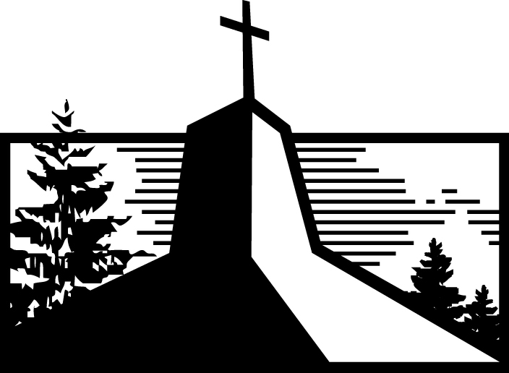
The Problem with Self-Sufficiency
Hosea 8:1-14

Three Ways God’s People Relied on Themselves

- ____________________ kings without _______________ God.
(Verses 4-6)

- _______________ in human __________ rather than God.
(Verses 7-10)

- _______________ according to their own _______________ rather than God’s.
(Verses 11-14)

THE RESULT God’s people would __________ what they __________.
(Verses 1-3, 7a)

Why Self-Sufficiency Isn’t All It’s Cracked Up to Be

- Like a minor wind, _______________ God might seem __________ at first, but it can grow into a _______________ hurricane.

- There will _______________ be a rock like the __________.

Relying on Jesus Today

- There’s a world of a difference between human _______________ and an “__________ this” attitude.

- Our _______________ life will always be one of the loudest indicators of __________ we’re _______________ on most.
4:8-9
Marttell Sánchez
May 15, 2022
Message #11 / Hosea
newlifeukiah.com/sermons
The Problem with Self-Sufficiency
Hosea 8:1-14

Three Ways God’s People Relied on Themselves

- SETTING UP kings without CONSULTING God.
(Verses 4-6)

- TRUSTING in human KINGS rather than God.
(Verses 7-10)

- WORSHIPING according to their own DESIRES rather than God’s.
(Verses 11-14)

THE RESULT God’s people would REAP what they SOWED.
(Verses 1-3, 7a)

Why Self-Sufficiency Isn’t All It’s Cracked Up to Be

- Like a minor wind, NEGLECTING God might seem SMALL at first, but it can grow into a DESTRUCTIVE hurricane.

- There will NEVER be a rock like the ROCK.

Relying on Jesus Today

- There’s a world of a difference between human RESPONSIBILITY and an “I GOT this” attitude.

- Our PRAYER life will always be one of the loudest indicators of WHOM we’re RELYING on most.
For Further Study
_________________________________________________________________________________________________
Getting Started
- In what ways does Israel express self-sufficiency in Sunday’s text?

- In what ways have you seen self-sufficiency at work in our culture today? In what ways can self-sufficiency creep into modern churches?

Digging Deeper
- In Psalm 127:1, Solomon sings, “Unless the Lord builds the house, the builders labor in vain.” What does this teach you about the importance of relying on God?

- Now read Psalm 31:1-5. In what ways does David express his reliance on God through this psalm? What does this teach you?

Driving It Home
- Sunday’s text invited us to consider how a small wind can end up as a catastrophic hurricane. In what ways have you seen the neglect of God, which seems small at the beginning, grow to become something destructive in others’ lives?

- What steps can you take this week to grow in your reliance on God?

